**Project Team 9**

This document contains all the deliverables as mentioned in the document stated in the blackboard.

**List**

1. Create a dimensional data model for the following data subsets of Schools K12 DW:
   1. Absences
   2. Discipline Behavior
   3. Academic Performance
   4. Special Programs
2. **Data Model for Absence records**

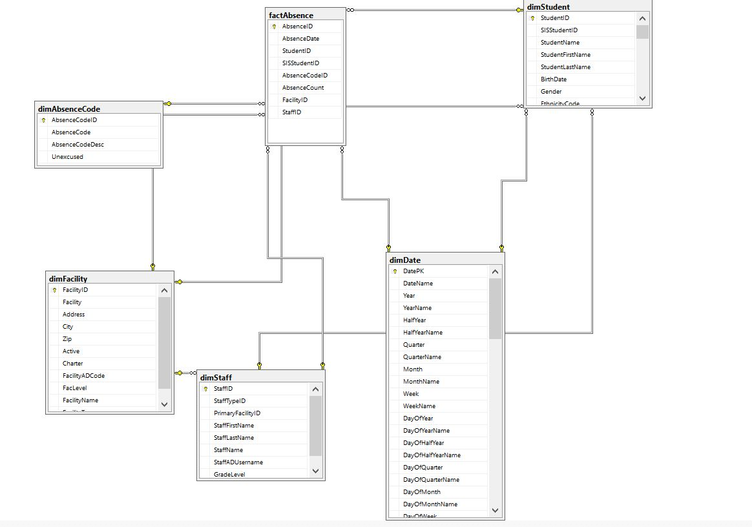

1. **Data Model for Discipline**

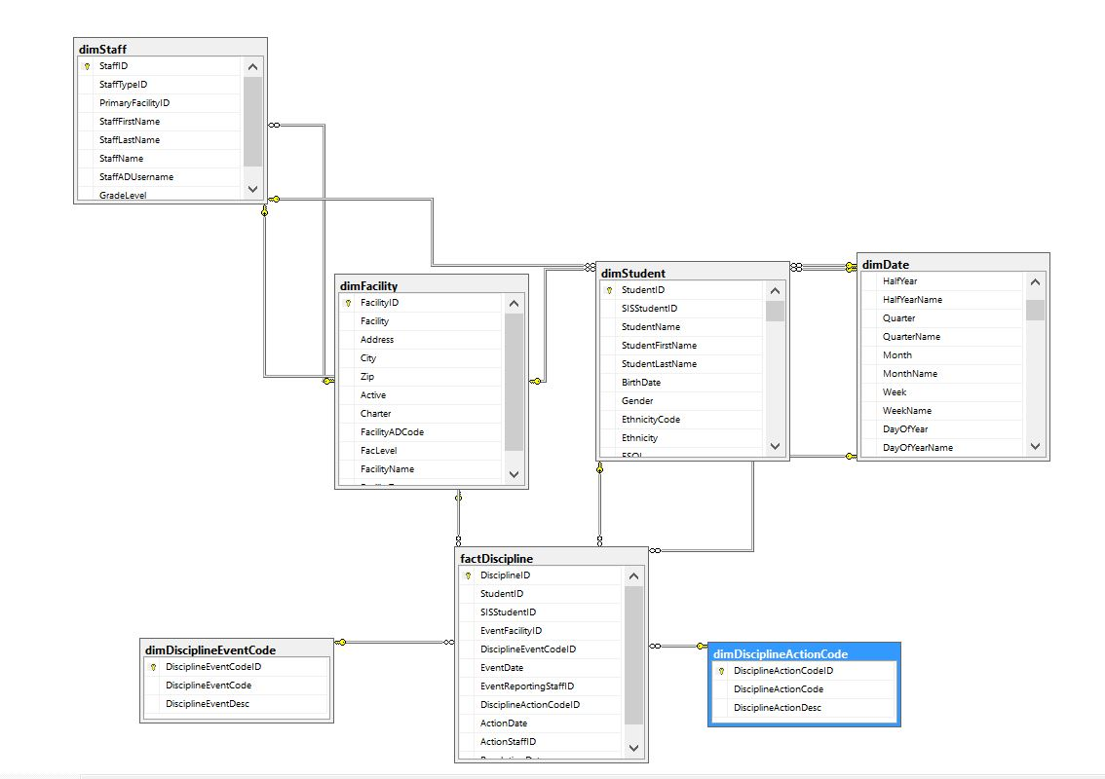

1. **Data Model for Academic Performance**

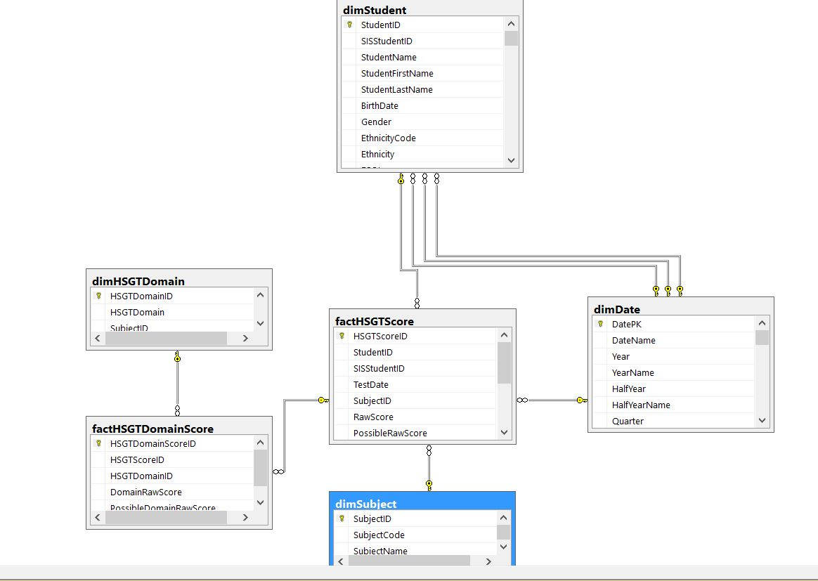

1. **Data Model for Special Programs**

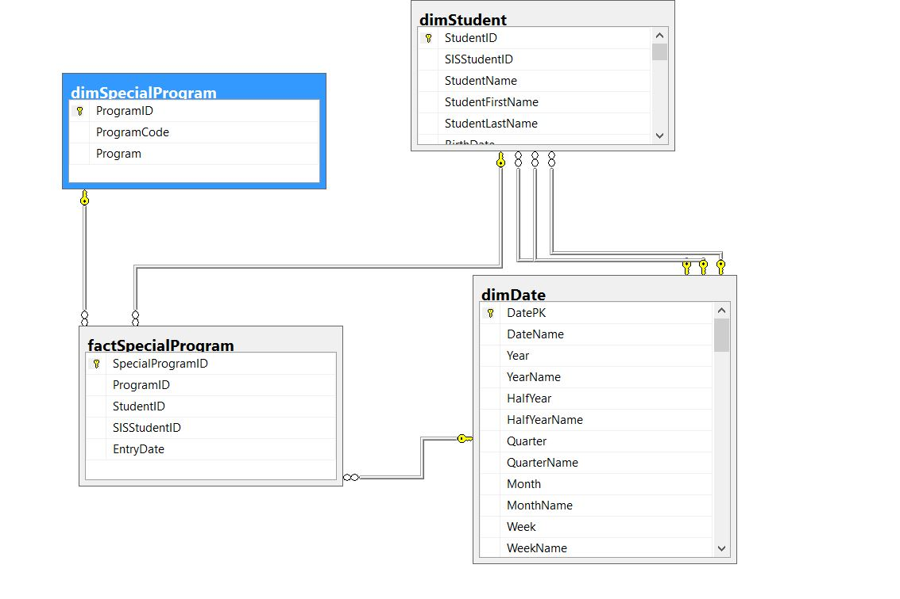

1. Create a description & list sample types of analysis/queries for each data subset from the following perspectives:
   * Parent point of View
   * Admin point of View
   * Faculty point of View
2. Write SQL queries for each of the sample queries above & present results

**Parent point of view**

ABSENCE

1. Main cause for absence on a particular date for my child

**select dbo.factAbsence.StudentID, dbo.dimStudent.StudentFirstName, dbo.dimAbsenceCode.AbsenceCodeDesc, dbo.dimDate.DatePK**

**from dbo.dimStudent inner join dbo.factAbsence on dbo.dimStudent.StudentID=dbo.factAbsence.StudentID**

**inner join dbo.dimAbsenceCode on dbo.dimAbsenceCode.AbsenceCodeID=dbo.factAbsence.AbsenceCodeID**

**inner join dbo.dimDate**

**on dbo.dimDate.DatePK=dbo.factAbsence.AbsenceDate**

**where dbo.dimStudent.StudentFirstName='Lola' and dbo.dimDate.DatePK='2008-12-14 00:00:00.000';**

1. Frequency of absence of my child per semester

**select dbo.dimStudent.StudentFirstName,count(dbo.factAbsence.Absence) as numberofTimes**

**from**

**dbo.dimStudent inner join dbo.factAbsence**

**on dbo.dimStudent.StudentID=dbo.factAbsence.StudentID**

**inner join dbo.dimAbsenceCode**

**on dbo.dimAbsenceCode.AbsenceCodeID=dbo.factAbsence.AbsenceCodeID**

**inner join dbo.dimDate**

**on dbo.dimDate.DatePK=dbo.factAbsence.AbsenceDate**

**where dbo.dimStudent.StudentFirstName='Lola' and dbo.dimDate.HalfYearName='Semester 2,**

**2008'**

**group by dbo.dimStudent.StudentfirstName;**

DISCIPLINE

1. What were the disciplinary action taken against my kid

**select dbo.dimDisciplineActionCode.DisciplineActionDesc,**

**dbo.factDiscipline.StudentID,dbo.dimStudent.StudentFirstName,dbo.dimDate.DatePK**

**from dbo.dimStudent**

**inner join dbo.factDiscipline**

**on dbo.dimStudent.StudentID=dbo.factDiscipline.StudentID**

**inner join dbo.dimDisciplineActionCode**

**on factDiscipline.DisciplineActionCodeID=dbo.dimDisciplineActionCode.DisciplineActionCodeID**

**inner join dbo.dimDate**

**on dbo.factDiscipline.ActionDate=dbo.dimDate.DatePK**

**where dbo.dimStudent.StudentFirstName='Kim' ;**

1. What is the most frequent used disciplinary actions given to my kid

**select count(*) as number, dbo.dimDisciplineActionCode.DisciplineActionDesc**

**from dbo.dimStudent**

**inner join dbo.factDiscipline**

**on dbo.dimStudent.StudentID=dbo.factDiscipline.StudentID**

**inner join dbo.dimDisciplineActionCode**

**on factDiscipline.DisciplineActionCodeID=dbo.dimDisciplineActionCode.DisciplineActionCodeID**

**where dbo.dimStudent.StudentFirstName='Kim'**

**group by dbo.dimDisciplineActionCode.DisciplineActionDesc ;**

PERFORMANCE

1. What was the score of my child (assuming name as lucas) for a particular date

**Select ds.SubjectName,dd.DateName,st.EnrollmentDate,st.StudentID,h.ScaledScore,h.PossibleScaledScore from dimStudent as st**

**inner join factHSGTScore as h**

**on h.StudentID = st.StudentID**

**inner join dimSubject as ds**

**on ds.SubjectID = h.SubjectID**

**inner join dimDate as dd**

**on dd.DatePK = h.TestDate**

**where st.StudentFirstName='Luca'**

**group by dd.DateName,st.EnrollmentDate,st.StudentID,h.PossibleScaledScore,h.ScaledScore,ds.SubjectName**

SPECIAL CLASSES

1. How many special programs were taken by my kid

**select count (*) as numberofclassesenrolled, dbo.dimStudent.StudentFirstName**

**from dbo.factSpecialProgram**

**inner join**

**dbo.dimSpecialProgram**

**on**

**dbo.dimSpecialProgram.ProgramID=dbo.factSpecialProgram.ProgramID**

**inner join dbo.dimStudent**

**on dbo.factSpecialProgram.StudentID=dbo.dimStudent.StudentID**

**where dbo.dimStudent.StudentFirstName='Andreas'**

**group by dbo.dimStudent.StudentFirstName**

**Admin point of view**

ABSENCE

1. Number of teachers absent on each day in calender year 2010

**select dd.DateName, count(*) as NoofStaffAbent from dimStaff as st**

**inner join factAbsence as d**

**on st.StaffID = d.StaffID**

**inner join dimAbsenceCode as da**

**on da.AbsenceCodeID = d.AbsenceCodeID**

**inner join dimDate as dd**

**on dd.DatePK = d.AbsenceDate**

**where dd.YearName = 'Calendar 2010'**

**group by dd.DateName,dd.DatePK**

**order by dd.DatePK**

1. Frequency of absence of a particular teacher per quarter

**select st.StaffName,dd.QuarterName, count(*) as NoofTimesAbsent from dimStaff as st**

**inner join factAbsence as d**

**on st.StaffID = d.StaffID**

**inner join dimAbsenceCode as da**

**on da.AbsenceCodeID = d.AbsenceCodeID**

**inner join dimDate as dd**

**on dd.DatePK = d.AbsenceDate**

**where st.StaffFirstName='Cyril'**

**group by st.StaffName,dd.QuarterName**

1. For each staff what was the frequency per absence action taken against him/her

**select StaffFirstName, count(*) as NoofTimes,da.AbsenceCodeDesc from dimStaff as st**

**inner join factAbsence as d**

**on st.StaffID = d.StaffID**

**inner join dimAbsenceCode as da**

**on da.AbsenceCodeID = d.AbsenceCodeID**

**group by st.StaffFirstName,da.AbsenceCodeDesc**

**order by st.StaffFirstName**

DISCIPLINE

1. For each faculty what was the frequency per disciplinary action taken against him

**select StaffFirstName, count(*) as NoofTimes,da.[DisciplineActionDesc] from dimStaff as st**

**inner join factDiscipline as d**

**on st.StaffID = d.ActionStaffID**

**inner join dimDisciplineActionCode as da**

**on da.DisciplineActionCodeID = d.DisciplineActionCodeID**

**group by st.StaffFirstName,da.DisciplineActionDesc**

**order by st.StaffFirstName**

PERFORMANCE

1. In which subject what was the average score for each subject

**select ds.SubjectID,ds.SubjectName,AVG(h.ScaledScore) as AverageScore from dimStudent as st**

**inner join factHSGTScore as h**

**on h.StudentID = st.StudentID**

**inner join dimSubject as ds**

**on ds.SubjectID = h.SubjectID**

**group by ds.SubjectID,ds.SubjectName**

SPECIAL PROGRAMS

1. How many students have been enrolled for the particular special program?

**select count(*) as TotalNumberOfStudents,da.ProgramCode,da.Program from dimStudent as st**

**inner join factSpecialProgram as d**

**on st.StudentID = d.StudentID**

**inner join dimSpecialProgram as da**

**on da.ProgramID = d.ProgramID**

**group by da.ProgramCode,da.Program**

1. Most popular special program based on maximum number of students enrolled

**select TOP 1 count(*) as TotalNumberOfStudents,da.ProgramCode,da.Program from dimStudent as st**

**inner join factSpecialProgram as d**

**on st.StudentID = d.StudentID**

**inner join dimSpecialProgram as da**

**on da.ProgramID = d.ProgramID**

**group by da.ProgramCode,da.Program**

**order by TotalNumberOfStudents DESC**

3.   In a particular calendar year, how many students enrolled for special programs

**select dd.YearName,da.ProgramCode,da.Program,count(*) as TotalNumberOfStudents from dimStudent as st**

**inner join factSpecialProgram as d**

**on st.StudentID = d.StudentID**

**inner join dimSpecialProgram as da**

**on da.ProgramID = d.ProgramID**

**inner join dimDate as dd**

**on dd.DatePK = d.EntryDate**

**group by da.ProgramCode,da.Program,dd.YearName**

**order by dd.YearName DESC**

**Faculty point of view**

ABSENCE

1. Number of Students absent on each day in calender year 2010

**select dd.DateName, count(*) as NoofStudentsAbsent from dimStudent as st**

**inner join factAbsence as d**

**on st.StudentID = d.StudentID**

**inner join dimAbsenceCode as da**

**on da.AbsenceCodeID = d.AbsenceCodeID**

**inner join dimDate as dd**

**on dd.DatePK = d.AbsenceDate**

**where dd.YearName = 'Calendar 2010'**

**group by dd.DateName,dd.DatePK**

**order by dd.DatePK**

1. Frequency of absence of a particular student per quarter

**select st.StudentID,dd.QuarterName, count(*) as NoofTimesAbsent from dimStudent as st**

**inner join factAbsence as d**

**on st.StudentID = d.StudentID**

**inner join dimAbsenceCode as da**

**on da.AbsenceCodeID = d.AbsenceCodeID**

**inner join dimDate as dd**

**on dd.DatePK = d.AbsenceDate**

**where st.StudentFirstName='Kim'**

**group by st.StudentID,dd.QuarterName**

DISCIPLINE

1. For each student what was the frequency per disciplinary action taken against him

**select StudentFirstName, count(*) as NoofTimes,da.[DisciplineActionDesc] from dimStudent as st**

**inner join factDiscipline as d**

**on st.StudentID = d.StudentID**

**inner join dimDisciplineActionCode as da**

**on da.DisciplineActionCodeID = d.DisciplineActionCodeID**

**group by st.StudentFirstName,da.DisciplineActionDesc**

**order by st.StudentFirstName**

1. For a particular student find the top disciplinary action that has be taken

**select TOP 1 count(*) as NoofTimes,StudentFirstName,da.[DisciplineActionDesc] from dimStudent as st**

**inner join factDiscipline as d**

**on st.StudentID = d.StudentID**

**inner join dimDisciplineActionCode as da**

**on da.DisciplineActionCodeID = d.DisciplineActionCodeID**

**group by st.StudentFirstName,da.DisciplineActionDesc having st.StudentFirstName = 'Abu'**

PERFORMANCE

1. For a particular subject(based on subject id) which student(based on student id) what were the scores

**select st.StudentID,st.StudentFirstName,st.StudentLastName,h.ScaledScore,h.PossibleScaledScore from dimStudent as st**

**inner join factHSGTScore as h**

**on h.StudentID = st.StudentID**

**inner join dimSubject as ds**

**on ds.SubjectID = h.SubjectID**

**where ds.SubjectID =9;**

SPECIAL PROGRAMS

1. How many special programs are taken per calendar year by a specific student

**select st.StudentID,st.StudentFirstName,st.StudentLastName,da.ProgramCode,da.Program from dimStudent as st**

**inner join factSpecialProgram as d**

**on st.StudentID = d.StudentID**

**inner join dimSpecialProgram as da**

**on da.ProgramID = d.ProgramID**

**where st.StudentFirstName = 'Gustavo'**

**order by st.StudentID**

1. Create OLAP (SSAS) cube for each data model:  
   1. **Absences**: The Microsoft Visual Studio was used in order to create OLAP cubes. The OLAP cubes were designed to inculcate a fact table with factAbsence and associated dimensions. The hierarchy for Date was drilled down to include the granularity of days, weeks, months and quarter for a particular year.
   2. **Discipline Behavior:** The Microsoft Visual Studio was used in order to create OLAP cubes. The OLAP cubes were designed to inculcate a fact table with factDiscipline Behavior and associated dimensions.
   3. **Academic Performance:** The Microsoft Visual Studio was used in order to create OLAP cubes. The OLAP cubes were designed to inculcate a fact table with factAcademic and associated dimensions.
   4. **Special Programs:** The Microsoft Visual Studio was used in order to create OLAP cubes. The OLAP cubes were designed to inculcate a fact table with factSpecialPrograms and associated dimensions.

Use PowerBI using OLAP cubes & display results of above queries/analysis

**Power BI Results**

**Admin’s point of view**

**ABSENCE**

1. Number of teachers absent on each day in calendar year 2010

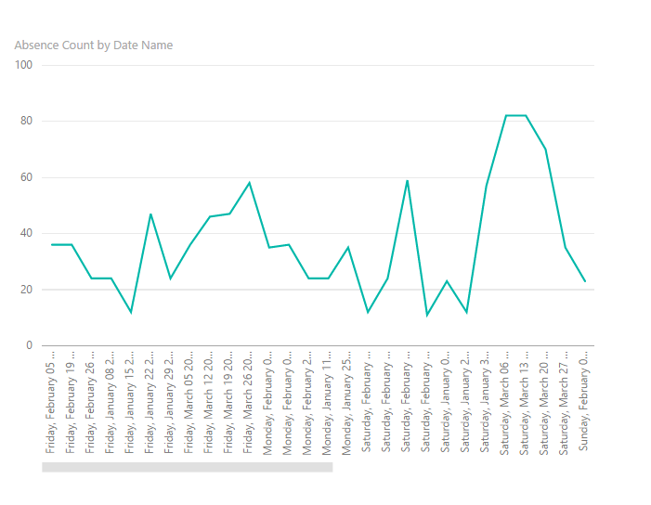

1. Frequency of absence of a particular teacher per quarter

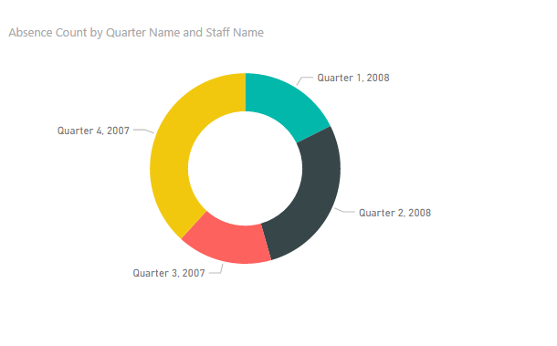

1. For each staff what was the frequency per absence action taken against him/her

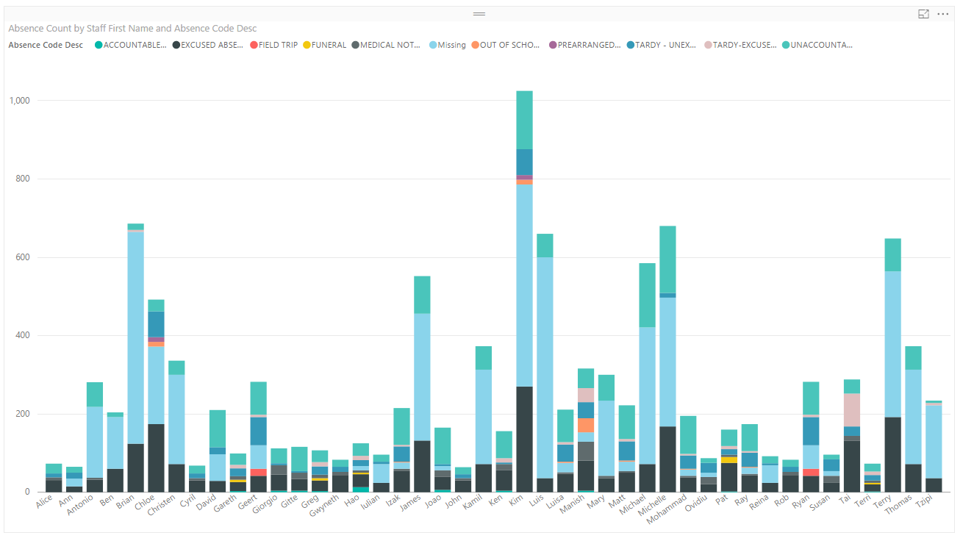

**DISCIPLINE**

1. For each faculty what was the frequency per disciplinary action taken against him

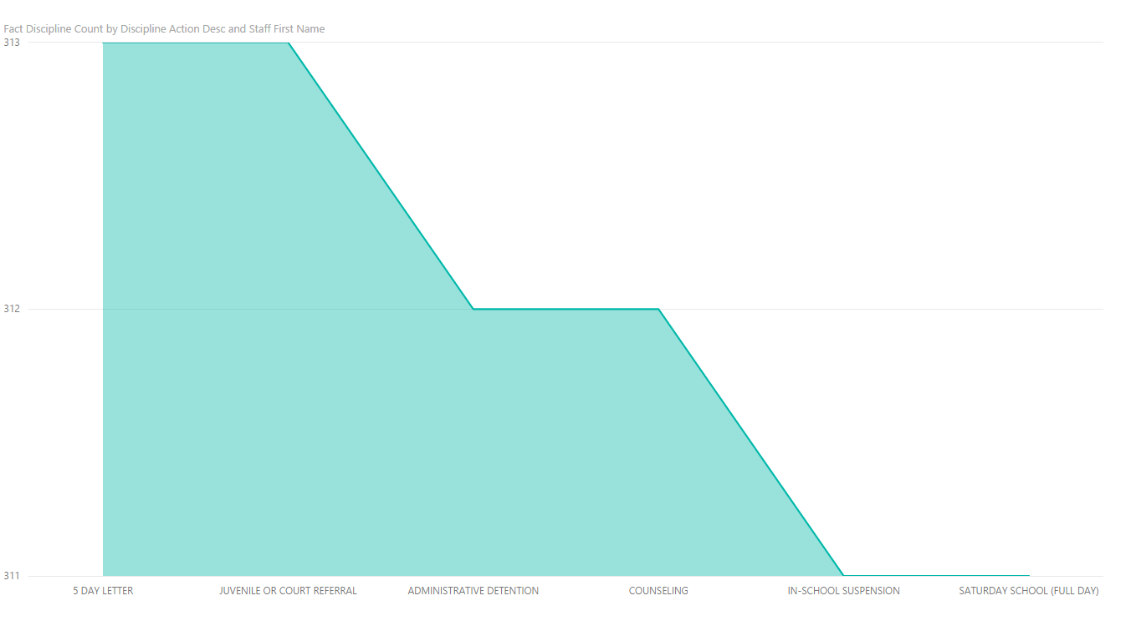

**SPECIAL PROGRAM**

1. How many students have been enrolled for the particular special program?

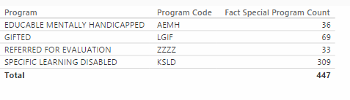

1. Most popular special program based on maximum number of students enrolled

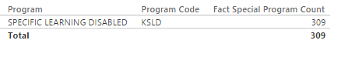

1. In a particular calendar year, how many students enrolled for special programs

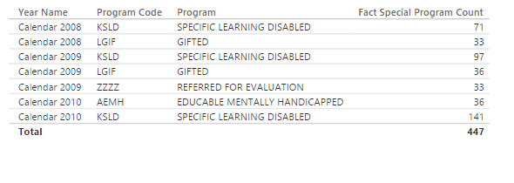

**Faculty’s Point Of View**

**ABSENCE**

1. Number of Students absent on each day in calendar year 2010  
     
     
   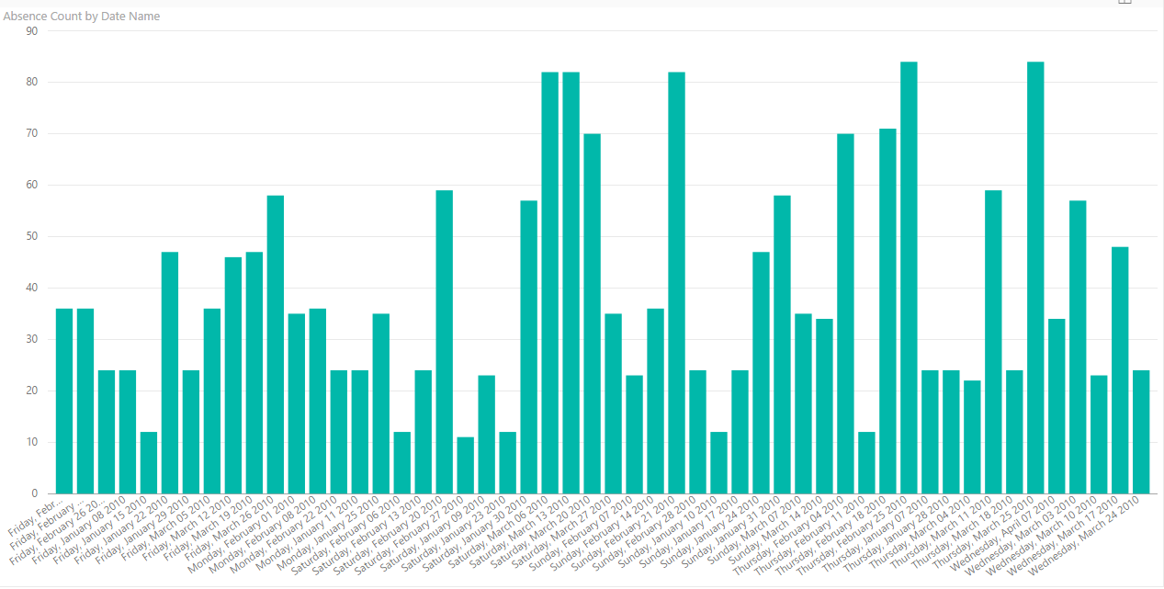
2. Frequency of absence of a particular student per quarter  
     
   Considering the student in this case is : **Kim**

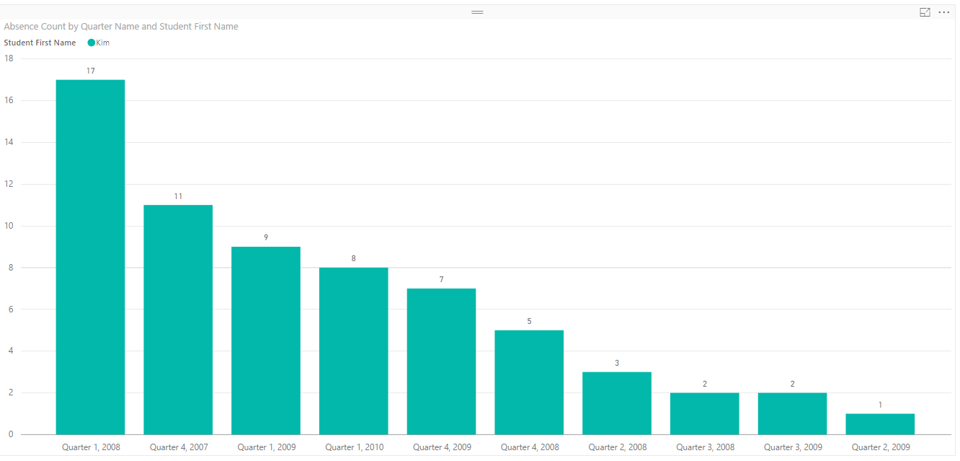

**DISCIPLINE**

1. For each student what was the frequency per disciplinary action taken against him

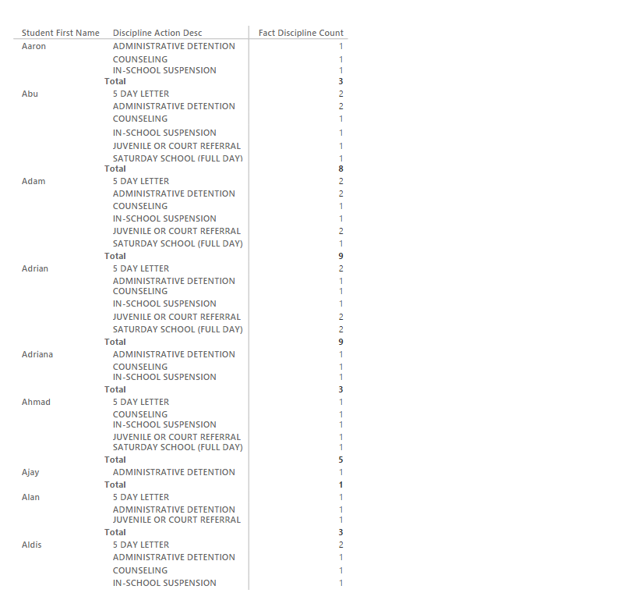

1. For a particular student find the top disciplinary action that has be taken

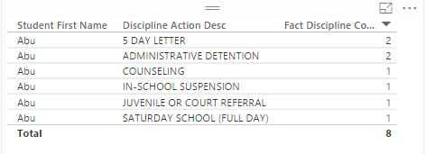

**PERFORMANCE**

1. For a particular subject(based on subject id) which student(based on student id) what were the scores

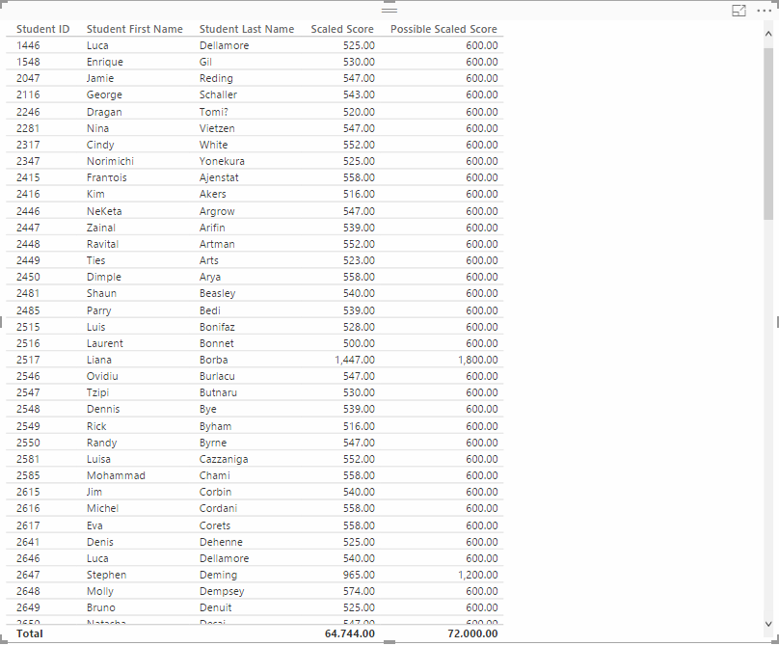

**SPECIAL PROGRAMS**

1. How many special programs are taken per calendar year by a specific student

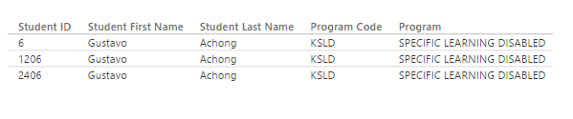

**Parent’s point of View**

**ABSENCE**

1. Main cause for absence on a particular date for my child :  
   Taking into consideration that the child’s name is **LOLA**

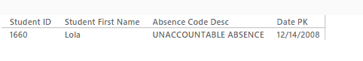

1. Frequency of absence of my child per semester  
     
   Taking into consideration that the child’s name is **LOLA**

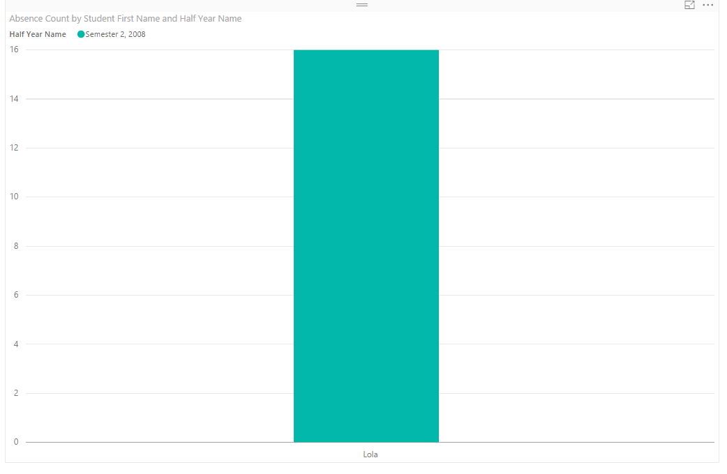

**DISCIPLINE**

1. What is the most frequent used disciplinary actions given to my kid

Considering the child’s name is **KIM**

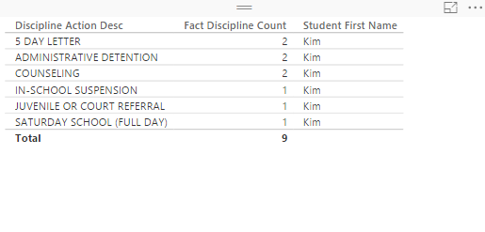

**PERFORMANCE**

1. What was the score of my child (assuming name as **LUCAS**) for a particular date

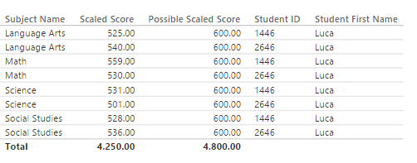

**SPECIAL CASES**

1. How many special programs were taken by my kid  
     
   Considering the child’s name is **ANDREA**

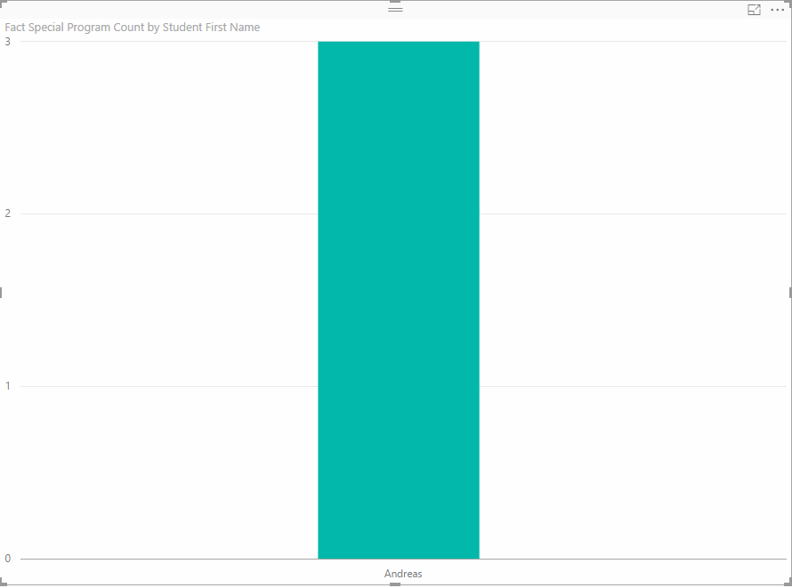

1. Create two databases using the flat file, each a different DBMS, that recreates the Schools_K12_DW dimensional model & perform queries (#4) against each database. Select 2 of the following 3 dbms:
   * Oracle
   * MySQL
   * PostgreSQL

**PostgreSQL Queries**

**Database Design and Management**

**Parent point of view**

ABSENCE

1. Main cause for absence on a particular date for my child

**select factAbsence.StudentID, dimStudent.StudentFirstName, dimAbsenceCode.AbsenceCodeDesc, dimDate.DatePK**

**from dimStudent inner join factAbsence on dimStudent.StudentID=factAbsence.StudentID**

**inner join dimAbsenceCode on dimAbsenceCode.AbsenceCodeID=factAbsence.AbsenceCodeID**

**inner join dimDate**

**on dimDate.DatePK=factAbsence.AbsenceDate**

**where dimStudent.StudentFirstName='Lola' and dimDate.DatePK='2008-12-14 00:00:00.000';**

1. Frequency of absence of my child per semester

**select dbo.dimStudent.StudentFirstName,count(*) as numberofTimes**

**from**

**dbo.dimStudent inner join dbo.factAbsence**

**on dbo.dimStudent.StudentID=dbo.factAbsence.StudentID**

**inner join dbo.dimAbsenceCode**

**on dbo.dimAbsenceCode.AbsenceCodeID=dbo.factAbsence.AbsenceCodeID**

**inner join dbo.dimDate**

**on dbo.dimDate.DatePK=dbo.factAbsence.AbsenceDate**

**where dbo.dimStudent.StudentFirstName='Lola' and dbo.dimDate.HalfYearName='Semester 2,**

**2008'**

**group by dbo.dimStudent.StudentfirstName;**

DISCIPLINE

1. What were the disciplinary action taken against my kid

**select dbo.dimDisciplineActionCode.DisciplineActionDesc,**

**dbo.factDiscipline.StudentID,dbo.dimStudent.StudentFirstName,dbo.dimDate.DatePK**

**from dbo.dimStudent**

**inner join dbo.factDiscipline**

**on dbo.dimStudent.StudentID=dbo.factDiscipline.StudentID**

**inner join dbo.dimDisciplineActionCode**

**on factDiscipline.DisciplineActionCodeID=dbo.dimDisciplineActionCode.DisciplineActionCodeID**

**inner join dbo.dimDate**

**on dbo.factDiscipline.ActionDate=dbo.dimDate.DatePK**

**where dbo.dimStudent.StudentFirstName='Kim' ;**

1. What is the most frequent used disciplinary actions given to my kid

**select count(*) as number, dimDisciplineActionCode.DisciplineActionDesc**

**from dimStudent**

**inner join factDiscipline**

**on dimStudent.StudentID=factDiscipline.StudentID**

**inner join dimDisciplineActionCode**

**on factDiscipline.DisciplineActionCodeID=dimDisciplineActionCode.DisciplineActionCodeID**

**where dimStudent.StudentFirstName='Kim'**

**group by dimDisciplineActionCode.DisciplineActionDesc ;**

PERFORMANCE

1. What was the score of my child (assuming name as lucas) for a particular date

**Select ds.SubjectName,dd.DateName,st.EnrollmentDate,st.StudentID,h.ScaledScore,h.PossibleScaledScore from dimStudent as st**

**inner join factHSGTScore as h**

**on h.StudentID = st.StudentID**

**inner join dimSubject as ds**

**on ds.SubjectID = h.SubjectID**

**inner join dimDate as dd**

**on dd.DatePK = h.TestDate**

**where st.StudentFirstName='Luca'**

**group by dd.DateName,st.EnrollmentDate,st.StudentID,h.PossibleScaledScore,h.ScaledScore,ds.SubjectName**

SPECIAL CLASSES

1. How many special programs were taken by my kid

**select count (*) as numberofclassesenrolled, dimStudent.StudentFirstName**

**from factSpecialProgram**

**inner join**

**dimSpecialProgram**

**on**

**dimSpecialProgram.ProgramID=factSpecialProgram.ProgramID**

**inner join dimStudent**

**on factSpecialProgram.StudentID=dimStudent.StudentID**

**where dimStudent.StudentFirstName='Andreas'**

**group by dimStudent.StudentFirstName**

**Admin point of view**

ABSENCE

1. Number of teachers absent on each day in calender year 2010

**select dd.DateName, count(*) as NoofStaffAbent from dimStaff as st**

**inner join factAbsence as d**

**on st.StaffID = d.StaffID**

**inner join dimAbsenceCode as da**

**on da.AbsenceCodeID = d.AbsenceCodeID**

**inner join dimDate as dd**

**on dd.DatePK = d.AbsenceDate**

**where dd.YearName = 'Calendar 2010'**

**group by dd.DateName,dd.DatePK**

**order by dd.DatePK**

1. Frequency of absence of a particular teacher per quarter

**select st.StaffName,dd.QuarterName, count(*) as NoofTimesAbsent from dimStaff as st**

**inner join factAbsence as d**

**on st.StaffID = d.StaffID**

**inner join dimAbsenceCode as da**

**on da.AbsenceCodeID = d.AbsenceCodeID**

**inner join dimDate as dd**

**on dd.DatePK = d.AbsenceDate**

**where st.StaffFirstName='Cyril'**

**group by st.StaffName,dd.QuarterName**

1. For each staff what was the frequency per absence action taken against him/her

**select StaffFirstName, count(*) as NoofTimes,da.AbsenceCodeDesc from dimStaff as st**

**inner join factAbsence as d**

**on st.StaffID = d.StaffID**

**inner join dimAbsenceCode as da**

**on da.AbsenceCodeID = d.AbsenceCodeID**

**group by st.StaffFirstName,da.AbsenceCodeDesc**

**order by st.StaffFirstName**

DISCIPLINE

1. For each faculty what was the frequency per disciplinary action taken against him

**select StaffFirstName, count(*) as NoofTimes,da.DisciplineActionDesc from dimStaff as st**

**inner join factDiscipline as d**

**on st.StaffID = d.ActionStaffID**

**inner join dimDisciplineActionCode as da**

**on da.DisciplineActionCodeID = d.DisciplineActionCodeID**

**group by st.StaffFirstName,da.DisciplineActionDesc**

**order by st.StaffFirstName**

PERFORMANCE

1. In which subject what was the average score for each subject

**select ds.SubjectID,ds.SubjectName,AVG(h.ScaledScore) as AverageScore from dimStudent as st**

**inner join factHSGTScore as h**

**on h.StudentID = st.StudentID**

**inner join dimSubject as ds**

**on ds.SubjectID = h.SubjectID**

**group by ds.SubjectID,ds.SubjectName**

SPECIAL PROGRAMS

1. How many students have been enrolled for the particular special program?

**select count(*) as TotalNumberOfStudents,da.ProgramCode,da.Program from dimStudent as st**

**inner join factSpecialProgram as d**

**on st.StudentID = d.StudentID**

**inner join dimSpecialProgram as da**

**on da.ProgramID = d.ProgramID**

**group by da.ProgramCode,da.Program**

1. Most popular special program based on maximum number of students enrolled

**select count(*) as TotalNumberOfStudents,da.ProgramCode,da.Program from dimStudent as st**

**inner join factSpecialProgram as d**

**on st.StudentID = d.StudentID**

**inner join dimSpecialProgram as da**

**on da.ProgramID = d.ProgramID**

**group by da.ProgramCode,da.Program**

**order by TotalNumberOfStudents DESC LIMIT 1**

3.   In a particular calendar year, how many students enrolled for special programs

**select dd.YearName,da.ProgramCode,da.Program,count(*) as TotalNumberOfStudents from dimStudent as st**

**inner join factSpecialProgram as d**

**on st.StudentID = d.StudentID**

**inner join dimSpecialProgram as da**

**on da.ProgramID = d.ProgramID**

**inner join dimDate as dd**

**on dd.DatePK = d.EntryDate**

**group by da.ProgramCode,da.Program,dd.YearName**

**order by dd.YearName DESC**

**Faculty point of view**

ABSENCE

1. Number of Students absent on each day in calender year 2010

**select dd.DateName, count(*) as NoofStudentsAbsent from dimStudent as st**

**inner join factAbsence as d**

**on st.StudentID = d.StudentID**

**inner join dimAbsenceCode as da**

**on da.AbsenceCodeID = d.AbsenceCodeID**

**inner join dimDate as dd**

**on dd.DatePK = d.AbsenceDate**

**where dd.YearName = 'Calendar 2010'**

**group by dd.DateName,dd.DatePK**

**order by dd.DatePK**

1. Frequency of absence of a particular student per quarter

**select st.StudentID,dd.QuarterName, count(*) as NoofTimesAbsent from dimStudent as st**

**inner join factAbsence as d**

**on st.StudentID = d.StudentID**

**inner join dimAbsenceCode as da**

**on da.AbsenceCodeID = d.AbsenceCodeID**

**inner join dimDate as dd**

**on dd.DatePK = d.AbsenceDate**

**where st.StudentFirstName='Kim'**

**group by st.StudentID,dd.QuarterName**

DISCIPLINE

1. For each student what was the frequency per disciplinary action taken against him

**select StudentFirstName, count(*) as NoofTimes,da.DisciplineActionDesc from dimStudent as st**

**inner join factDiscipline as d**

**on st.StudentID = d.StudentID**

**inner join dimDisciplineActionCode as da**

**on da.DisciplineActionCodeID = d.DisciplineActionCodeID**

**group by st.StudentFirstName,da.DisciplineActionDesc**

**order by st.StudentFirstName**

1. For a particular student find the top disciplinary action that has be taken

**select TOP 1 count(*) as NoofTimes,StudentFirstName,da.[DisciplineActionDesc] from dimStudent as st**

**inner join factDiscipline as d**

**on st.StudentID = d.StudentID**

**inner join dimDisciplineActionCode as da**

**on da.DisciplineActionCodeID = d.DisciplineActionCodeID**

**group by st.StudentFirstName,da.DisciplineActionDesc having st.StudentFirstName = 'Abu'**

PERFORMANCE

1. For a particular subject(based on subject id) which student(based on student id) what were the scores

**select st.StudentID,st.StudentFirstName,st.StudentLastName,h.ScaledScore,h.PossibleScaledScore from dimStudent as st**

**inner join factHSGTScore as h**

**on h.StudentID = st.StudentID**

**inner join dimSubject as ds**

**on ds.SubjectID = h.SubjectID**

**where ds.SubjectID =9;**

SPECIAL PROGRAMS

1. How many special programs are taken per calendar year by a specific student

**select st.StudentID,st.StudentFirstName,st.StudentLastName,da.ProgramCode,da.Program from dimStudent as st**

**inner join factSpecialProgram as d**

**on st.StudentID = d.StudentID**

**inner join dimSpecialProgram as da**

**on da.ProgramID = d.ProgramID**

**where st.StudentFirstName = 'Gustavo'**

**order by st.StudentID**